DEMView: 3-D Visualization of DEM Error

Michael B. Gousie
Department of Math & Computer Science
Wheaton College
Massachusetts, USA
mgousie@wheatoncollege.edu

Michael Smith
School of Geography, Geology and the Environment
Kingston University
Kingston-upon-Thames, UK
michael.smith@kingston.ac.uk

Abstract—It is well known that a digital elevation model (DEM) may contain systematic or other errors. In many 3-D visualization systems, problems in the data may be highlighted, but it is often difficult for the viewer to discern the exact nature of the problem. We present DEMView, a viewing and error assessment system specifically for use with DEMs. The system displays a DEM in 3-D with the usual translation, rotation, and zooming tools. However, the system incorporates a suite of visual (qualitative) and statistical (quantitative) assessment tools that help a researcher determine and analyze errors and uncertainty in a given DEM. A case study shows the efficacy of the system..
Keywords: DEM; error; viewer; 3-D; visualization

Introduction
The digital elevation model (DEM), where elevation values are stored in a regular grid, is ubiquitous in computer geo-processing. A specific DEM may be created via one of many methods, such as interpolating from contours or LIDAR point clouds, or derived from interferometric SAR. No matter how the DEM is computed, it will invariably contain systematic or other measurement or estimation problems; e.g., the interpolation of sparse data. Similarly, a DEM may show uncertainties in the data due to data representation; e.g., differences in DEM resolutions (Fisher, 2006).
DEM errors may be displayed by any number of visualization or geographical information systems. These visualizations range from simply rendering the DEM via a shaded-relief map, to overlaying colors/textures representing the magnitude of various quantified errors, to adding special glyphs to indicate additional information such as direction. No matter what the visualization, two problems are manifest: (1) it is often difficult for the viewer to perceive small scale problems within the context of an entire DEM and (2) it may be quite time consuming to find the desired functions in a large system, or the user is required to write a script to realize the desired functionality. Here we describe a prototype visualization system built solely for the purpose of viewing DEMs and assessing errors. One of the novel features is a “profile cutter” that allows the user to see small scale details in 2-D within the context of a 3-D DEM visualization.

Related Work
The problem of assessing error and/or uncertainty in a DEM can be broken into two parts: (1) quantifying the error and (2) producing a visualization for assessed errors. Various approaches to ascertaining the extent of DEM error have been proposed (Fisher, 2006) and these are outlined below.
A standard uncertainty measure is the root mean square error (RMSE), which compares a DEM height point with a corresponding elevation from an accurate source (Rinehart, 1988). However, RMSE only provides a global measure of the validity of a DEM. Carrara et al. (Carrara, 1997) use several analysis techniques, including determining if DEM heights fall between contour elevations. One way to test this is to create profile plots with the contour elevations highlighted (Gousie, 2005), while another method is to use elevation histograms to show if there is a linear fit between contours (Carrara, 1997; Reichenbach, 1993). One can also compute the smoothness of a DEM by computing the total squared curvature (Briggs, 1974) or, similarly, finding local curvature. Fisher (1998) computed several statistics after comparing a DEM with established spot heights and computed a probable viewshed. Errors, based on grid bias, can be found by comparing drainage networks extracted by multiple rotations of the DEM (Chearleux-Demargne, 2000). Rigorous statistical models have also been proposed (Carlisle, 2005).
Visualization of error gives the viewer immediate feedback to potential problems, with Wood and Fisher (1993) early proponents of such techniques. They compared several interpolated DEMs by displaying visualizations of aspect, Laplacian filtering that highlights sudden changes in elevation, RMSE, and shaded relief. Much work has been done in uncertainty visualization, for example using glyphs, translating/rotating surface patches to highlight potential error and altering lighting parameters (Pang, 1996; Johnson, 2003). MacEachren et al. (2005) provide a comprehensive overview of the state of visualizing uncertainty in geospatial domains.
There are many GIS that have good 3-D visualization capability and at least some uncertainty visualization features, of which the following is a sampling: textures are shown to be useful for terrain visualization (Dollner, 2000); Terrafly (Rishe, 2004) displays satellite imagery and other data in various resolutions; GeoZui3D (Ware, 2001) supports multiple linked views where the user can view the overall area and a smaller portion at a much greater resolution; Brooks (2005) describes 2-D and 3-D views of the same data; Landserf incorporates some error capabilities (Wood, 1996, Raper, 2002), including shaded relief, curvature visualization, peak classification, and others; Wiggenhagen (2000) describes a tool dedicated to displaying geographic areas and some errors using orthoimages; a thorough statistical and visual comparison between a DEM computed from contours and LIDAR data (Oksanen, 2006); and VisTRE (Healey, 2006), a system designed expressly for visualizing terrain errors, guided by psychophysical studies to maximize the effectiveness of the visualizations while limiting perceptual biases.
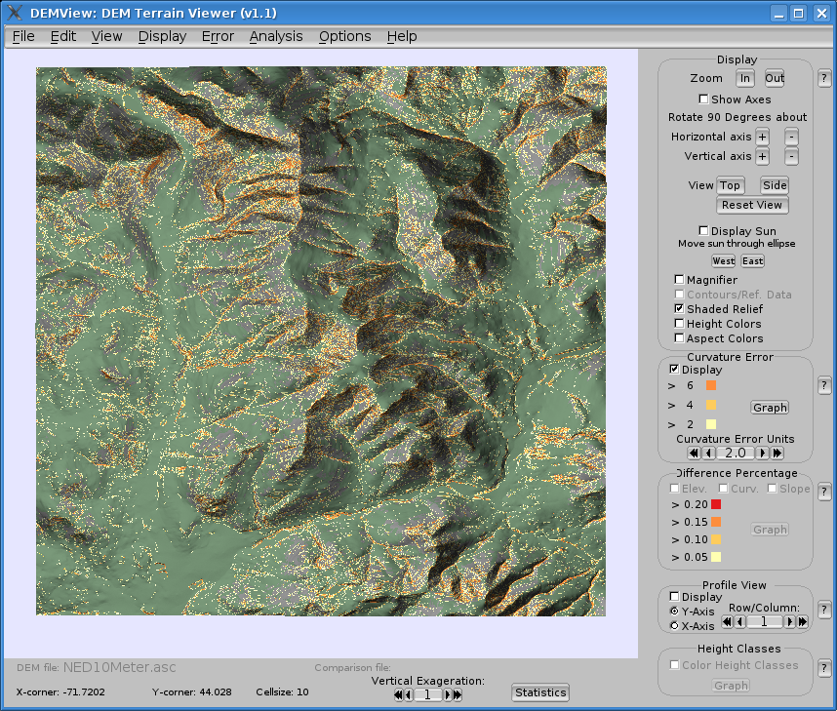
Figure 1. DEMView showing DEM of Franconia with curvature error; beige indicates a curvature over two feet with the hue changing to orange indicating curvature over six feet

Overview of DEMView (DEM Viewer)
DEMView is a prototype system for DEM error visualization, written in C++ with the OpenGL Application Programming Interface (API) for the graphics rendering, the OpenGL Utility Toolkit (GLUT) for the window system, and Fast Light Toolkit (FLTK) for the graphical user interface (GUI). Fig. 1 shows the system displaying one of the study areas, a 1709 x 1773 10-meter DEM taken from the 7.5' USGS National Elevation Dataset covering Franconia, NH. The program reads data files in standard ARC/INFO ASCII grid format. Note how the visualization shows a grayer color in areas above the tree line and where the slope is steep. The user may specify the tree line elevation and the appropriate slope angle for the particular map area.
A distinguishing feature of this visualization system is that the GUI is designed specifically for visualizing uncertainty in DEMs. All features are displayed on the front panel, as well as being available through menus. The system includes standard functionality of DEM visualization, including rotation and zooming. Common positions, such as top or side view, can be achieved through one button click instead of using the mouse to move the surface until the desired view is found. Contours or sparse data can be overlayed on the DEM; the latter can often be difficult to see on large DEMs, however in DEMView they are displayed using cubes that are easily seen. Contour, sparse, or full DEM data can be used to compare with the initial DEM, and several assessment visualizations can be displayed. In all cases, no special scripts or multiple levels of menus are required.

Curvature and Difference Visualization
The overall smoothness of a DEM can be computed by finding the total squared curvature, C_{sq} (Briggs, 1974):
The total squared curvature may be biased if there are large problem areas in a DEM. To mitigate this, an indication of local smoothness can be found by averaging the local, or absolute, curvature found at a point i, j:
The value of C_{abs} is the curvature at a specific point and can be displayed in DEMView, where the threshold is chosen by the viewer. The curvature is displayed via different hues, where the original terrain surface color indicates no error (little curvature) and progressing through darker hues of orange, as shown in Fig. 1. The colors were chosen using ColorBrewer (http://colorbrewer2.org). The numeric labels on the GUI change dynamically to indicate the current level of curvature relative to the displayed colors.
One of the strengths of the system is to be able to visualize differences between a DEM and reference data. The user simply loads the two files and then chooses the appropriate option. To visualize elevation discrepancies between reference data and a DEM, each reference height point v is compared to the corresponding elevation u in the DEM to find the local difference error d at point i,j:
where v is the elevation in the reference DEM. Following Carrara (1997), d should not be greater than 5% of the contour interval. Thus, similar to the mechanism described for curvature error, colors are assigned to elevations that have d greater than 5%, 10%, 15%, and 20%, where the highest difference is displayed in red. In the same way, the slope or curvature at each point of a DEM can be compared to the reference data, where the percentage indicates the relative differences.

Height Class Frequency Visualization
If the source data is contours, then the DEM values within an area bounded by a contour pair should vary almost linearly, indicating an absence of artifacts such as terracing. DEM elevations are grouped into integer intervals between two contours and then reclassified into relative elevations (Carrara, 1997). For example, if 1200-1220 represents a contour pair, then the relative elevations, or height classes, would be 0, 1, 2, ..., 19 corresponding to the elevations of 1200, 1201, 1202, ..., 1219. The height classes are computed and the surface is displayed in the green terrain color with the absolute frequency of the relative heights shown in graduated color from green to orange. The brighter the orange, the higher the absolute frequency of that height class, indicating that the slope is not linear between successive contours. The actual absolute frequencies are displayed as well for graphing purposes. It must be noted that the absolute frequency is a global measure that is applied to individual points, and thus the visualization is only a guide as to where there is potential for error. In other words, all points with the same color indicate they are in the same height class.

Quantitative Statistics
The user can also opt to have DEMView display various statistics. These include total squared curvature, maximum curvature, and the count for each of the curvature error levels (which can also be shown as a graph). If the DEM is being compared to reference data, comparison statistics are computed as well. These include the counts for difference error levels and the RMSE. Additional statistics will be included in future versions of the system.

The Profile Cutter
Whilst many systems offer visualizations that enable the viewer to observe errors in general, it is often difficult to zoom in on a small area to ascertain minute differences between a DEM and reference data. Other systems offer a 2-D view of a profile displayed in a separate window, which completely disassociates this data from the DEM. The profile cutter is a semi-transparent planar rectangle that is orthogonal to the surface and displayed in 3-D. The cutter enables the viewer to make a vertical “slice’ through the DEM to better see the profile at any x or y position. The position can be changed dynamically through buttons on the GUI, including moving the profile incrementally. Alpha blending makes the cutter semi-transparent, thus showing the profile within the context of the remaining DEM in the background. Fig. 2a shows the profile cutter slicing through a portion of the Franconia DEM that is being compared to reference contours. The profile is shown as a continuous white line; the glyphs show where reference contours intersect with the profile.
In the reference data set, if there exists a valid elevation at an x, y position, then an optional glyph can be displayed in the profile. The glyph is a vertical line segment of constant length that has the following properties:
- If the primary and secondary elevations match within a user-specified threshold, then the glyph is rendered in white vertically centered at the profile.
- If the elevation in the DEM is above the reference elevation, then the glyph is rendered in a red hue proportional to the difference of the two elevations, where almost white indicates a slight difference and bright red indicates a large difference. In addition, the bottom endpoint of the line segment is at the elevation contained in the reference data.
- If the elevation in the DEM is below the reference elevation, then the glyph is rendered in shades of blue, with dark blue indicating a large difference. The endpoint at the top of the line segment is at the elevation contained in the reference data.
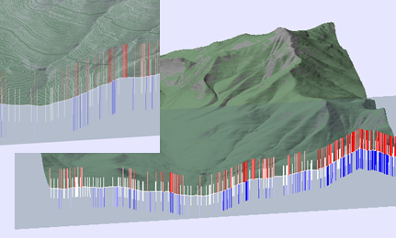
Figure 2. (a) The profile cutter slicing the Franconia DEM; glyphs show accuracy levels compared to source contours. (b) Close-up view including contour visualization.

- If glyphs are turned off, the reference profile is shown as a line only, in the same hues as described above denoting the closeness of the match with the primary DEM.
Thus, the glyphs can show a DEM's accuracy compared to reference data at a glance. In Fig. 2a, it is easy to observe that the DEM's accuracy compared to the reference contours is lower in the steeper sections on the right side compared to the left. Fig. 2b shows a close-up of the profile, glyphs, and the Franconia surface in the background with the contours made visible. Visualizing such multivariate data in context is difficult to achieve in a 2-D system.

Case Study
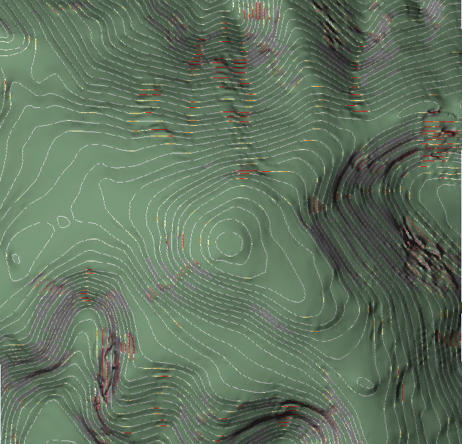
Figure 3. DEM of Mt. Washington, NH, showing contours and elevation differences.
In this section we compare two DEMs computed from the same contours using DEMView and similar tools available in LandSerf. Fig. 3 shows an 800 x 800 DEM of Mt. Washington (NH), computed from contours using the ARC/INFO TOPOGRID, with the contours from the reference file turned on and curvature displayed. A portion of the surface in the SW corner is identifiable as anomalous. Fig. 4a shows the same DEM displayed in LandSerf, zoomed into the SW corner with curvature error turned on. Note that there is no way to show the curvature and the contours at the same time. In both cases, the curvature coloring indicates anomalies in the bowl area. In LandSerf, the user can find an arbitrary profile by clicking and dragging a line on the surface; a 2-D profile centered at the problematic area is shown in Fig. 4b. Once the user chooses the profile on the main window, the profile is displayed in a new window, but the main window loses all contextual information connected with the profile. Furthermore, the scaling of the profile is such that it is difficult to identify problems with the surface. In contrast, DEMView allows the user to view the profile in the context of the surface, as show in Fig. 5; the glyphs highlight the intersection of the contours and show how the surface significantly deviates from the reference elevations.

Conclusions and Future Work
Here we have presented DEMView, a DEM and error visualization system that incorporates a “profile cutter” that can be used to view a dynamically movable 2-D profile in the context of a 3-D surface. The user can identify potential anomalous regions in the DEM, using the orthogonal slice, that may otherwise not be possible in a 3-D environment. In particular, the profile slice allows the layering of two data sets, a DEM and a reference data file, in the same context space, giving the viewer new visualization options for comparing topographic data. Glyphs provide data on the differences between two files at matching locations. The system, which is purpose-built for DEM error visualizations, incorporates traditional visualization tools such as viewing slope, aspect, curvature, and height class frequency. The system can also generate visualizations to display the differences of these measurements between two data sets, as well as compute global error statistics such as RMSE.

Future development of DEMView will see the addition of further accuracy measures and the provision of novel visualization techniques. A particular focus will be the visualization of multiple error metrics at the same time.

References
Briggs, I. (1974) Machine contouring using minimum curvature. Geophysics. Volume 39(1), 39–48, February 1974.
Brooks, S. and Whalley, J.L. (2005) A 2D/3D hybrid geographical information system. In Proceedings of ACM GRAPHITE (pp. 323–330). Dunedin, New Zealand.
Carlisle, B.H. (2005) Modelling the spatial distribution of DEM error.Transactions in GIS. Volume 9(4),521–540.
Carrara, A, Bitelli, G, and Carla, R. (1997) Comparison of techniques for generating digital terrain models from contour lines. International Journal of Geographical Information Science. Volume 11(5), 451–473.
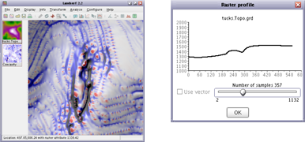
Figure 4. (a) Close-up view of problem area using LandSerf. (b) Corresponding profile.
Charleux-Demargne, J. and Puech, C. (2000) Quality assessment for drainage networks and watershed boundaries extraction from a digital elevation model (dem). In 8th ACM Symposium on GIS. (pp. 89–94) Washington, D.C.
Dollner, J., Baumann, K., and Hinrichs, K. (2000) Texturing techniques for terrain visualization. In Proceedings of the 11th IEEE Visualization Conference (VIS 2000) (pp. 227–234).
Fisher, P. (1998) Improved modeling of elevation error with geostatistics. GeoInformatica. Volume 2(3), 215–233.
Fisher, P.F. and Tate, N.J. (2006) Causes and consequences of error in digital elevation models. Progress in Physical Geography. Volume 30(4), 467–489.
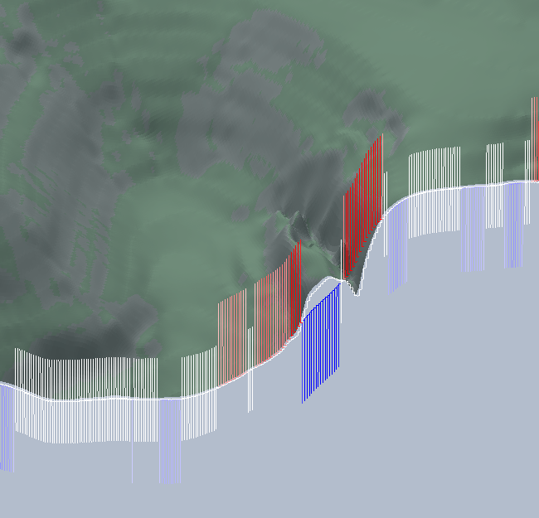
Figure 5. Profile comparison of TOPOGRID DEM with reference DEM.

Gousie, M.B. and Franklin, W.R. (2005) Augmenting grid-based contours to improve thin plate DEM generation. Photogrammetric Engineering & Remote Sensing. Volume 71(1),69–79.
Healey, C.G. and Snoeyink, J.(2006) Vistre: A visualization tool to evaluate errors in terrain representation. In Proceedings, 3rd International Symposiumon 3D Data Processing, Visualization and Transmission (3DPVT 2006). Chapel Hill, North Carolina.
Johnson, C.R. and Sanderson, A.R. (2003) A next step: Visualizing errors and uncertainty. IEEE Computer Graphics & Applications. Volume 23(5), 6–10.
MacEachren, A.M., Robinson, A., Hopper, S., Gardner, S., Murray, R., Gahegan, M., and Hetzler, E. (2005) Visualizing geospatial information uncertainty: What we know and what we need to know. Cartography and Geographic Information Science. Volume 32 (3), 139-169.
Oksanen, J. and Sarjakoski, T. (2006) Uncovering the statistical and spatial characteristics of fine toposcale DEM error. International Journal of Geographical Information Science. Volume 20(4), 345-369.
Pang, A. T., Wittenbrink, C.M., and Lodha, S. K. (1996) Approaches to uncertainty visualization. The Visual Computer. Volume 13(8), 370-390.
Raper, J., Dykes, J. Wood, J., Mountain, D., Krause, A., and Rhind, D. (2002) A framework for evaluating geographical information. Journal of Information Science. Volume 28(1), 51–62.
Reichenbach, P., Pike, R.J., Acevedo, W., and Mark, R.K. (1993) A new landform map of Italy in computer-shaded relief. Bollettino Geodesia a Scienze Affini. Volume 52, 22-44.
Rinehart, R.E. and Coleman, E.J. (1988) Digital elevation models produced from digital line graphs. In Proceedings of the ACSM-ASPRS Annual Convention. Volume 2, 291–299. American Congress on Surveying and Mapping, American Society for Photogrammetry and Remote Sensing.
Rishe, N., Sun, Y., Chekmasov, M., Andriy, S., and Graham, S. (2004) System architecture for 3d terrafly online gis. In Proceedings of the IEEE Sixth International Symposium onMultimedia Software Engineering (MSE2004), (pp. 273–276).
Ware, C., Plumlee, R., Arsenault, R., Mayer, L.A., and Smith, S. (2001) Geozui3d: Data fusion for interpreting oceanographic data. In Proceedings of the MTS/IEEE Conference and Exhibition(OCEANS 2001). Volume 3 (pp. 1960–1964).
Wiggenhagen, M. (2000) Development of real-time visualization tools for the quality control of digital terrain models and orthoimages. In International Archives of Photogrammetry and Remote Sensing (IAPRS). Volume 33 (pp. 987-993). Amsterdam.
Wood, J.D. (1996) The Geomorphological Characterisation of Digital Elevation Models. PhD thesis, University of Leicester, UK.
Wood, J.D. and Fisher, P.F. (1993) Assessing interpolation accuracy in digital elevation models. IEEE Computer Graphics and Applications. Volume 13 (2), 48-56.

