The Wheaton TechnoLegacy

Detailed Functional Specification

v 2.0

by
Amy Hopkinson
and
Karen Grieb

Class of 2009

TABLE OF CONTENTS

Introduction ………………………………………………………………………………….. Page 3
General Description …………………………………………………………....……………. Page 3
Goals …………………………………………………………………………………….…... Page 3
User Interface ……………………………………………………………………….……….. Page 4
Main Screen Topic Timelines …………………..………………….………………. Page 4
Clickable Decade Sections……..………………………….………………. Page 5
Fast Forward / Rewind Buttons…..………………………………………... Page 6
Zoomed In Decade View ……….…………………………………………………... Page 7
Clickable Event Ticks…………………………………………………….... Page 8
Back Button ……………………………………………………………….. Page 8
Event Window………………………………………………………………………. Page 9
Event Next/Previous Buttons……………………………………………... Page 10
Picture Enlargement………………………………………………………. Page 10
Event Description Scrollbar………………………………………………. Page 11
Closing Event Window…………………………………………………… Page 11
Email Link………………………………………………………………… Page 12
Data Storage …………………………………………………………….…………………. Page 12
Use Cases ………………………………………………………………..…………………. Page 12
Limitations ………………………………………………………………..………….......... Page 13

Introduction

The Wheaton TechnoLegacy educates people about the presence of computers over the course of history at Wheaton College in Norton, MA and allows users to contribute to an ongoing interactive timeline representing key technological advances at Wheaton College. The design of the project is such that continuation of the timeline into the future can be gracefully implemented by an editor. This timeline will be hosted on the Wheaton website.

General Description

The timeline is an interactive Flash movie hosted on the Wheaton web server and updated by an administrator. Upon loading the movie, the user sees a set of timelines that each correspond to a different subset of events. The user can click upon any decade on the timelines, and the Flash movie will display a zoomed in version of that range of dates with clickable event tick marks. In order to access decades that are not visible on the main screen, there are four buttons with which the user can scroll forwards and backwards through time (See the section User Interface, pg 4).
Each event on each timeline, when clicked, brings up a separate window within the movie below the zoomed in timeline of that decade. This window has more information such as the date, title of the event, description, any user comments that have been sent to the administrator, and potentially a picture if there is one associated with the event. At the bottom of the event window there is a link for potential user contributions. This link will open a separate browser window with a form that is submitted to the administrator through email. The administrator adds any user-based content underneath the description with the name of the user that provided it.
As mentioned before, there will be multiple timelines on the main screen. Each of these timelines represents a different event topic related to Wheaton technology. Some events will need to be cross-referenced to multiple topics and hence will appear on more than one of the timelines. The two timeline topics that we will be implementing are “Computer Museum” and “History of the Wheaton Website”. The website timeline will have events such as releases of new designs for the Wheaton website and dates marking the introduction of services such as WINDOW or Blackboard. We are leaving room for three additional timelines to make a total of five within the project. These additional timelines will not appear in the movie unless the administrator initializes them for the purpose of a new subset and adds his or her own content to the XML file (See the section Data Storage, pg 12).

Goals

Our main goal is to present the history of computing at Wheaton in an easily accessible and visually stimulating manner. Without our endeavors, this valuable history could easily be lost. Computer science is a relatively new department when compared to some of the other subjects offered at Wheaton, and it is important to record these early beginnings.
It is also important to take note of the fact that time does not stop in May when we graduate, and that Wheaton will continue to advance in the field of technology. Therefore our second goal is to ensure that this timeline can be easily added to by the Wheaton community and maintained by the administrator in the future.

User Interface

Topic Timelines

Each of the different timelines shown on the main screen represents a different subset of events with a common topic. Some events may be listed on multiple timelines.

When the user hovers over one of these timelines, it will become larger; the two adjacent timelines will assume a size that is halfway between the timeline in focus and the farther away timelines. Here the cursor is hovering over the first timeline:
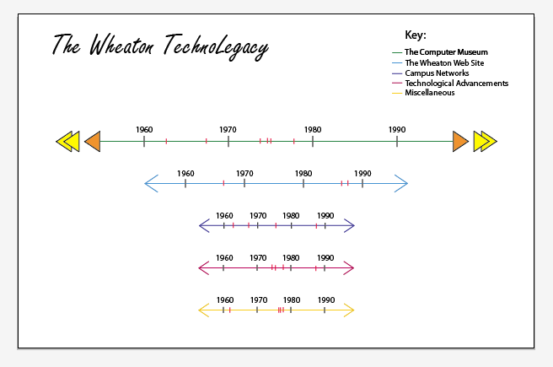

The cursor is hovering over the second timeline:

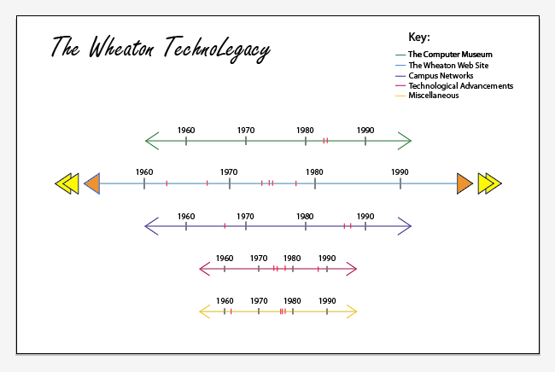

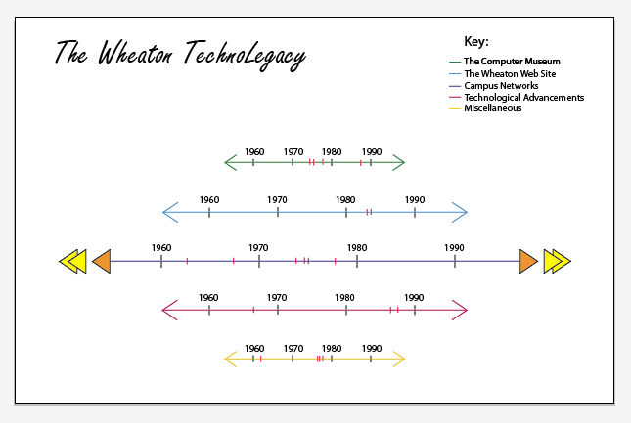The cursor is hovering over the third timeline:

Clickable Decade Sections

When on the main screen, the user must click on a decade in order to access the events shown on the timeline. To show the user the presence of content, each decade will become highlighted when the user hovers over it with the cursor. Every event that is present on each of the topic timelines will be displayed here although the user will have to zoom into the appropriate decade timeline in order to select the individual event. When a decade is clicked, the user will be shown a new screen with the zoomed in view of the decade from the topic timeline that he or she has chosen. Only the events on that timeline will be shown and all other topic timelines must be accessed by returning to the main screen.

Here the cursor is hovering over the ’70-’80 decade. Click to enter the decade timeline:
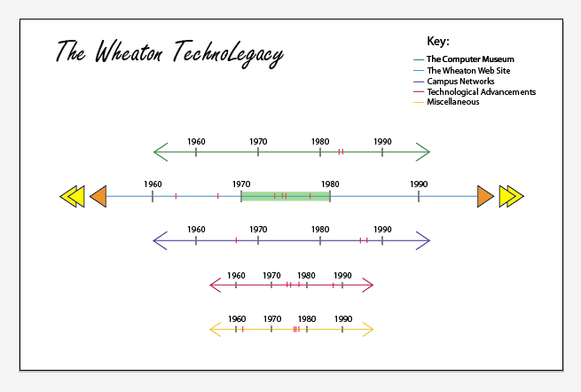

Fast Forward / Rewind Buttons

There are four buttons in this set, two on each side, which only appear on the main screen. The two innermost buttons, represented as single triangles, have two functions. When the left single triangle is clicked once, the timeline will shift one decade into the past, and when the right single triangle is clicked once, the timeline will shift one decade into the future. Likewise, when the double triangles are clicked once, the timeline will shift an entire visible length in the same relative directions.
When these same buttons are clicked and held, the user can scroll through the timeline fluidly. The single triangles will induce a slow scrolling motion while the double triangles will be faster for quicker scrolling.
Note that all timelines present on the main screen will scroll together, even though the buttons will only appear directly next to the timeline in focus. This will ensure that the user can easily compare events on the different timelines.
The cursor has just held the left orange triangle for a short while. Notice the timelines have shifted slightly into the past and new events have shown up on the left:

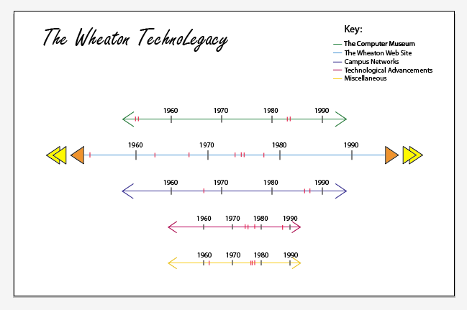

Zoomed In Decade View

There is a finite timeline at the top of the screen with clickable events shown for that decade on that topic timeline. Depending on which decade the user has chosen, the timeline will be displayed in a relevant theme.
For example, earlier decades will be reminiscent of a simple terminal window:

More recent decades will showcase abilities such as color and higher text resolution:

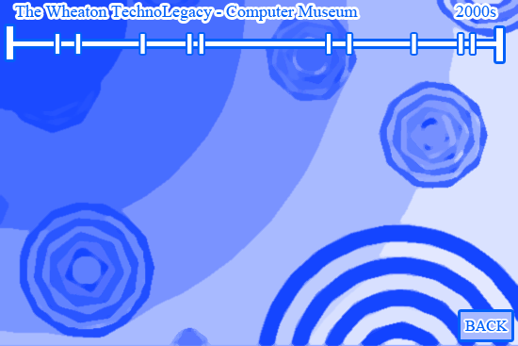

Clickable Event Ticks

These tick marks appear on the decade timeline, each representing a single event. When the user hovers over an event, the date of that event will appear and disappear when the user removes the cursor. When the user clicks an event, the event window will appear below.
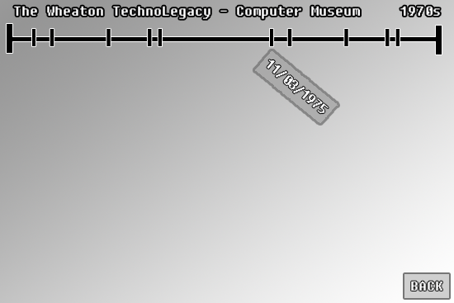

Back Button

This button appears in the decade view and is used to return to the main screen so that the user might select another decade or timeline.

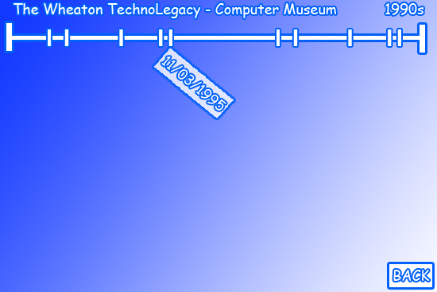

Event Window

By clicking on each individual tick on the timeline, represented in button form, the user can zoom in to view the event page for that date. This shows the user within the flash movie the information associated with that event, including the title, date, description, picture, and any user-generated content that has been submitted.

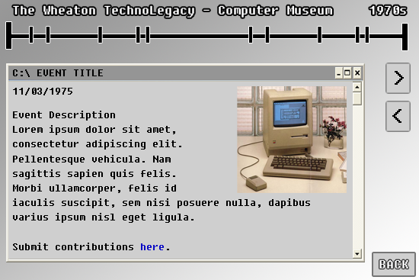

The dates of the events will still appear if the user hovers the cursor over the tick on the timeline:
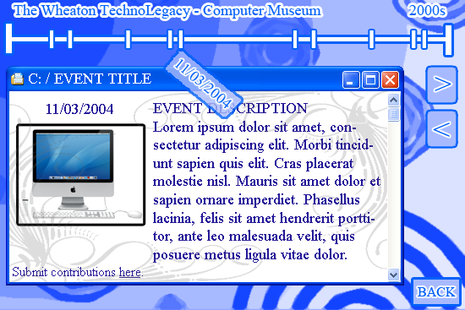

Event Next/Previous Buttons

While the user is reading any particular event details, there are two buttons present on the flash movie screen labeled ">" and "<", representing the next and previous events. These buttons allow the user to navigate chronologically through the timeline and browse the events in the order in which they occurred.
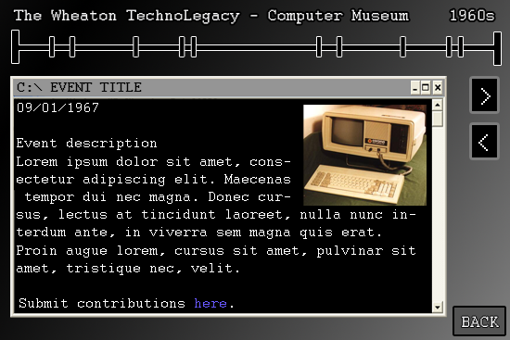

Picture Enlargement

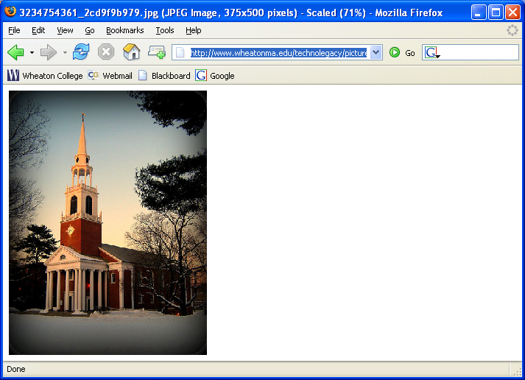When a user is viewing an individual event screen, they may click on any associated pictures in the window to view an enlarged version of the photo in a new window, separate from the flash movie.

Event Description Scrollbar

If an event has a long description that cannot fit into one flash screen, a scrollbar is present with which the user may scroll up and down to read all of the text. User comments are added after the description of the event, which may be another cause for scrolling.
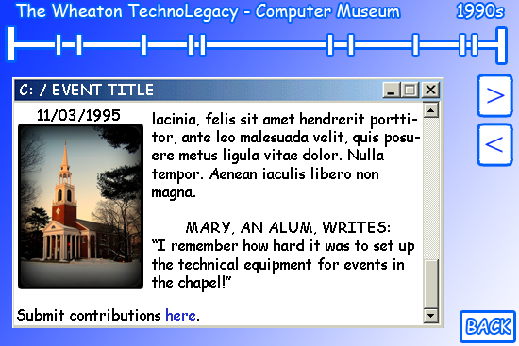

Closing Event Window

To close an event window, the user may click the X button on the top right of the window or the back button in the bottom right corner. The X button will simply close the event window while the user remains in the zoomed in decade view. The back button will bring the user back to the main screen with the multiple topic timelines.

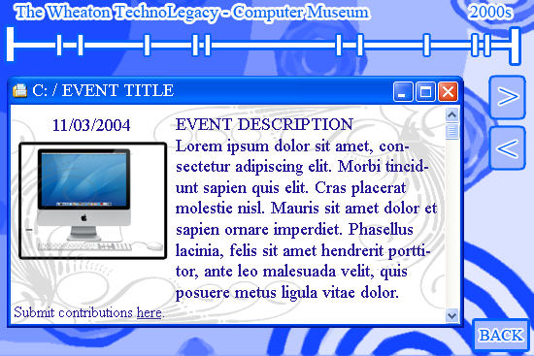

Email Link

There is a link at the bottom of each event window that will bring the user to a separate browser window. This page will have a form that he or she may fill out and a “Submit” button that will automatically send the contents to the administrator’s timeline email address. Here users may submit comments or additional information to be added to the timeline. An email address will be provided for other forms of media that cannot be submitted through the form, such as images. The administrator is responsible for checking this email address and updating the timeline accordingly.

Data Storage

The data for each event is stored in one XML file that is hosted on the Wheaton web server along with the flash movie file. The data for the decade themes is stored in a separate XML file. Future edits and additions to the timeline can be made by modifying these XML files only; the flash movie file is static and does not need to be edited. By using a second XML file for the decade themes, we feel that it will be easier for the administrator to introduce new themes without unnecessarily editing event data.

Use Cases

Pierre, a Wheaton College student, is doing a school project in his art history class in the year 2050. His assignment involves discussing the history of mediums in the art world and he wants to find out when students at Wheaton started using computers for the graphics in their art projects. Pierre finds the interactive timeline through searching the Wheaton website. He easily finds the information he wants by selecting the label scheme called "Technological Investments" that will highlight all of the dates at which Wheaton purchased new state-of-the-art computing equipment. By reading the description of each of the events, Pierre is able to discern which purchases benefit the art department. Pierre is able to scroll chronologically through these events along the timeline. Pierre is so happy that such a useful tool existed for him on the Wheaton College website that he tells all his friends about it.

Mary, a Wheaton College alumna, remembers the days when computers first came to Wheaton and wants to reminisce. She looks around on the internet for articles from those days but they are scarce. She finally finds our helpful timeline on the Wheaton website and is astonished by the great wealth of detail that she uncovers. She homes in on the range of dates when she was a student at Wheaton and reads each event description eagerly. Upon reaching one particular date that stands out in her memory (the addition of public access computers in the library), Mary is shocked to find no mention of it whatsoever on the timeline. Nearly blinded by fury, Mary sees the email link on the timeline encouraging her to contact the administrator. The realization that she is capable of contributing appeases her rage while enriching the experience for future alumni visiting the site. Later, she sees the results of her email posted on the timeline in the user-based content section below the event description, thanks to the efforts of the administrator.

Mark, a Wheaton College professor, has been stuck with the role of timeline administrator. He is the faculty member responsible for checking the email address provided in the timeline for users' contributions. While checking the timeline email one day, he sees Mary the alumna's message. He takes the information from Mary and edits the XML file, adding her remarks to the list of user contributions for the specified event.
After completing Mary's request, Mark returns to checking email. He finds another timeline-related request, this time from a current Wheaton staff member who has recently upgraded his equipment to current standards and wishes to be mentioned on the timeline. This means that Mark will have to create a new event on the timeline. Mark defines the date, title, description and picture of the event in the XML file by inserting a new record at the end. When the timeline reloads on the website, the new information will be included. Note that Mark, as the editor, has not made any changes to the actual Flash file but is, in fact, only modifying the XML file.

Limitations

This timeline needs an active administrator that can handle modifications in the XML file. It is also the responsibility of this administrator to filter the user-submitted content at his or her discretion. Also, the computers used by the administrators and users must have a fairly recent version of Flash.

